**Harold’s Vasement**

# Design Brief

*V1.0.0*

By

## Seojin Jeong

Game Development Studio I

Professor Samoff

Fall 2021

# Abstract

Tetris, puzzles, and hidden narratives! Use your imagination to shed new light on objects while tagging along an emotional journey.

## Genre

Retro 2D adventure

## Platform

Online (including mobile web) and gameboy handheld (or emulator)

## Time intervals

Real-time

## Player modes

Single player

## ESRB rating

E

## Target audience

puzzle games, or story driven text based games

# Primary game play

Your character Harold goes on an emotional journey recovering from undiagnosed depression. And by solving the puzzles and tetris in the room, you help Harold to be filled up in his void–Harold literally has a visible hole in his chest. Each level is a place for Harold to rediscover elements in his life in the new light as you turn the items around, or rearrange them to complete the puzzle.

In the gameplay, players will have to use their imaginations through the multiple mind teasers and optical illusions that build up on or have connections from the last puzzle. The pixel-fied items are abstract and able to be interpreted in various ways. Deciding the right tetris rearrangement is important to the whole gameplay as it calls for emotional compassion.

The core mechanic is start/ select (Z, X, Enter) in interacting with multiple puzzle pieces.

# Maps

## Start screen

## 

Title screen

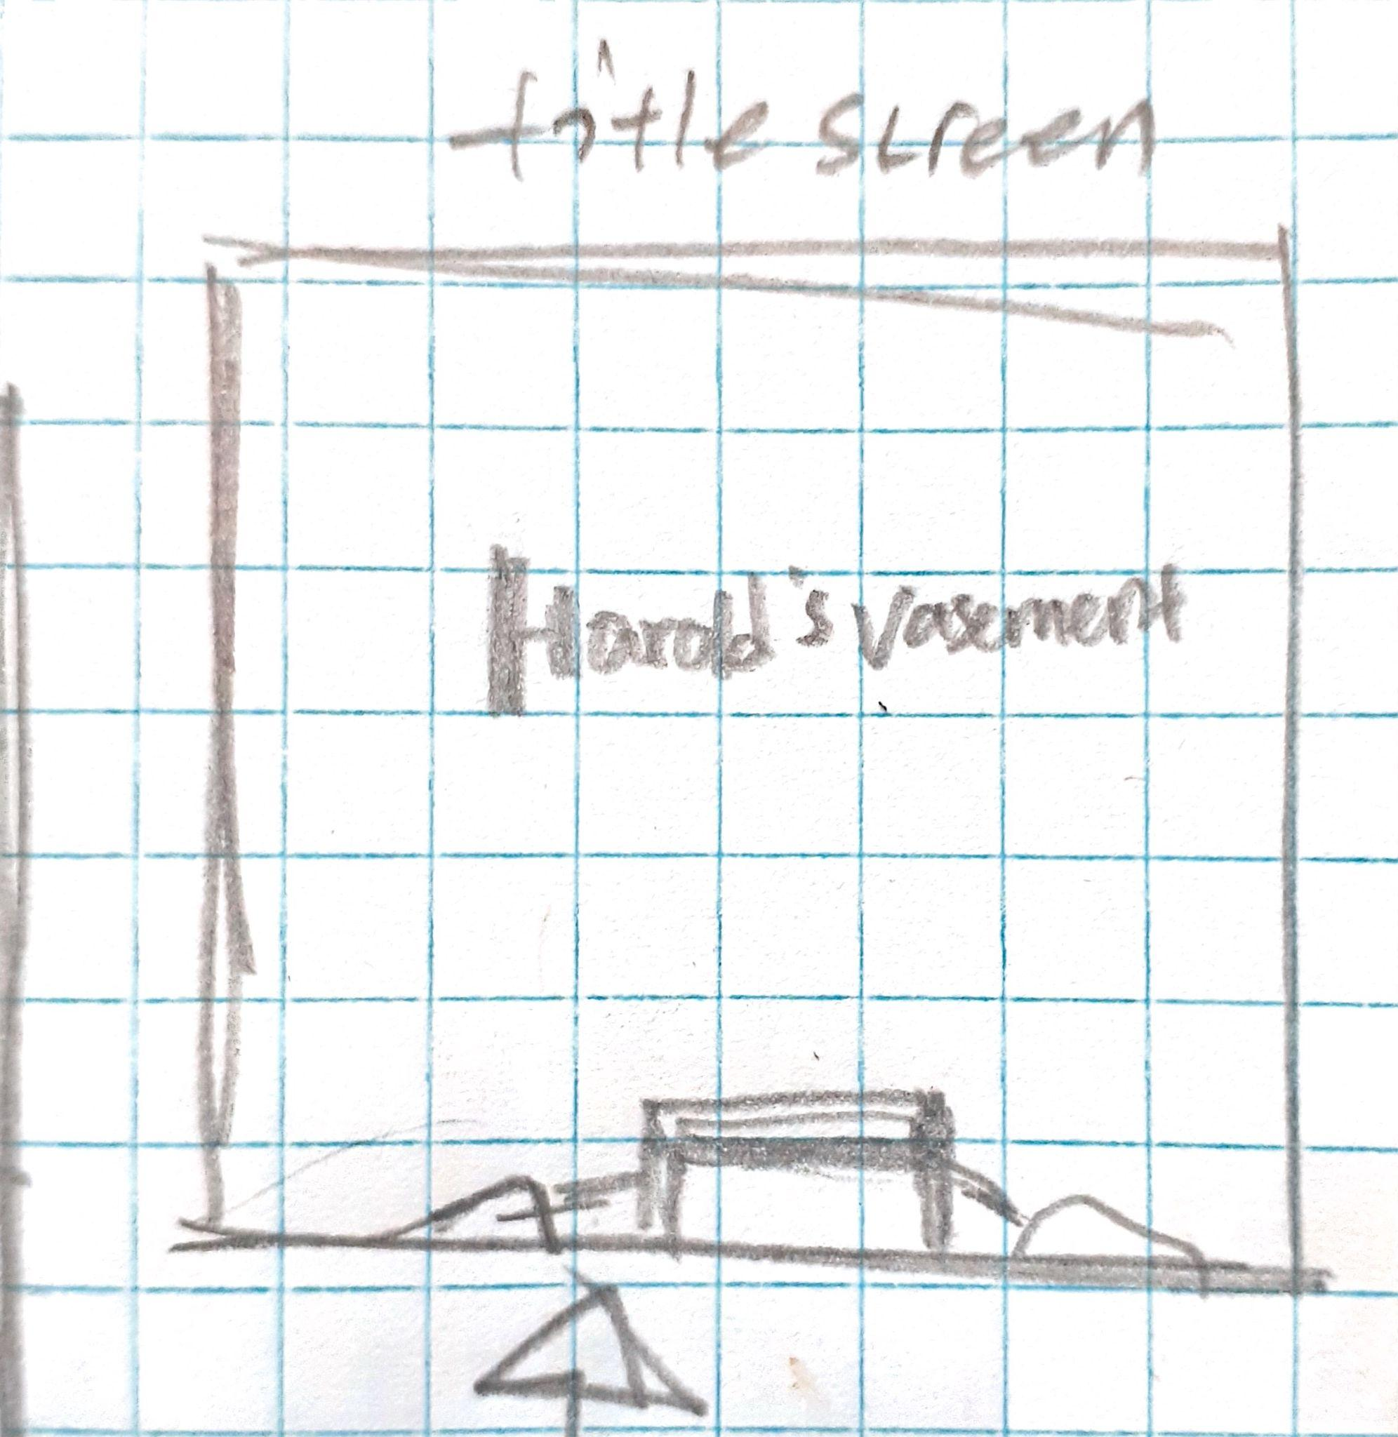

## Level Puzzles

## Top Down map

## 

## 

## 

## Final game play scene

## Start screen



Title screen

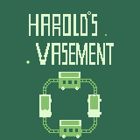

## In-game map



This is the first level where Harold wakes up to his hole in the chest.

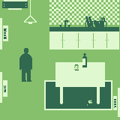

Living room.